EXP NO.1: Develop a portfolio website yourself which gives details about yourself for a potential recruiter.

Aim:
To develop a portfolio website myself which gives details about myself for a potential recruiter.

Algorithm:
Step1: Define CSS variables for colors and glass effect.
Step 2: Style body and html for full height and font.
Step 3: Create animated gradient background.
Step 4: Design glass sections with blur and transparency.
Step 5: Style headings and text for readability.
Step 6; Design button with hover effects.
Step 7: Build responsive grid for project cards.
Step 8: Style contact form with inputs, textarea, button.
Step 9: Add footer with simple text.
Step 10: Structure HTML with background, header, sections, and footer.

Program:

index.html
<!DOCTYPE html>
<html lang="en">
<head>
<meta charset="UTF-8" />

<meta name="viewport" content="width=device-width, initial- scale=1.0"/>

<title>My Portfolio</title>
<link rel="stylesheet" href="style.css" />
</head>
<body>
<div class="background"></div>
<header class="glass-section">
<h1>Hello, I'm Mohamed Hamdan</h1>
<p>Web Developer | Designer | Coder</p>
<a href="#contact" class="btn">Let's Connect</a>
</header>
<section class="glass-section" id="about">
<h2>About Me</h2>
<p>
I'm a creative web developer who loves building aesthetic and dynamic websites. With a passion for clean code and beautiful design,
I create digital experiences that people enjoy using.
</p>
</section>
<section class="glass-section" id="projects">
<h2>Projects</h2>
<div class="project-list">
<div class="project-card">
<h3>Project One</h3>
<p>A cool app that solves a problem you care about.</p>

<a href="#">View</a>
</div>
<div class="project-card">
<h3>Project Two</h3>
<p>A website that shows your design and dev skills.</p>
<a href="#">View</a>
</div>
<div class="project-card">
<h3>Project Three</h3>
<p>A full-stack project with database and API.</p>
<a href="#">View</a>
</div>
</div>
</section>
<section class="glass-section" id="contact">
<h2>Contact Me</h2>
<form>
<input type="text" placeholder="Your Name" required />
<input type="email" placeholder="Your Email" required />
<textarea placeholder="Your Message" required></textarea>
<button type="submit">Send</button>
</form>
</section>
<footer>
<p>© 2025 Mohamed Hamdan. All rights reserved.</p>

</footer>
</body>
</html>

style.css
:root {
--glass-bg: rgba(255, 255, 255, 0.1);
--glass-border: rgba(255, 255, 255, 0.3);
--accent: #ff6ec4;
--white: #fff; } body, html { height: 100%; font-family: 'Segoe UI', sans-serif; color: var(--white); scroll-behavior: smooth;
} .background { position: fixed; width: 100%; height: 100%; top: 0; left: 0;
margin: 0; padding: 0;

background: linear-gradient(45deg, #ff6ec4, #7873f5, #4bc0c8,
#c779d0); background-size: 400% 400%; animation: gradient 15s ease infinite; z-index: -1;
}
@keyframes gradient {
0% { background-position: 0% 50%; }
50% { background-position: 100% 50%; }
100% { background-position: 0% 50%; }
}
.glass-section { max-width: 900px; margin: 4rem auto; background: var(--glass-bg); backdrop-filter: blur(15px); -webkit-backdrop-filter: blur(15px); border: 1px solid var(--glass-border); padding: 3rem 2rem; border-radius: 20px; box-shadow: 0 8px 32px rgba(0,0,0,0.25); text-align: center;
}
h1 { font-size: 2.5rem;

margin-bottom: 0.5rem;
} h2 { font-size: 2rem; margin-bottom: 1.5rem; color: var(--accent); } p { font-size: 1.1rem; line-height: 1.6; margin-bottom: 1.5rem;
}
.btn { padding: 0.75rem 1.5rem; background: rgba(255, 255, 255, 0.2); border: 1px solid var(--glass-border); border-radius: 25px; color: var(--white); text-decoration: none; transition: 0.3s; } .btn:hover { background: rgba(255, 255, 255, 0.4); }
.project-list {

display: grid; grid-template-columns: repeat(auto-fit, minmax(240px, 1fr)); gap: 1.5rem; }
.project-card { background: rgba(255, 255, 255, 0.15); border: 1px solid var(--glass-border); padding: 1.5rem; border-radius: 15px; backdrop-filter: blur(10px); transition: transform 0.3s;
}
.project-card:hover { transform: translateY(-5px);
}
.project-card a { display: inline-block; margin-top: 1rem; color: var(--accent); text-decoration: none; font-weight: bold;
} form { display: flex; flex-direction: column;

gap: 1rem; max-width: 500px; margin: 0 auto; } input, textarea, button { padding: 0.8rem 1rem; border-radius: 10px; border: none; font-size: 1rem; } input, textarea { background: rgba(255, 255, 255, 0.2); color: var(--white); border: 1px solid var(--glass-border);
} textarea { resize: vertical; min-height: 100px; } button { background: var(--accent); color: #fff; cursor: pointer;
transition: background 0.3s;
}

button:hover { background: #e255ae;
} footer { text-align: center; padding: 2rem; font-size: 0.9rem; color: #eee;
}
Output:

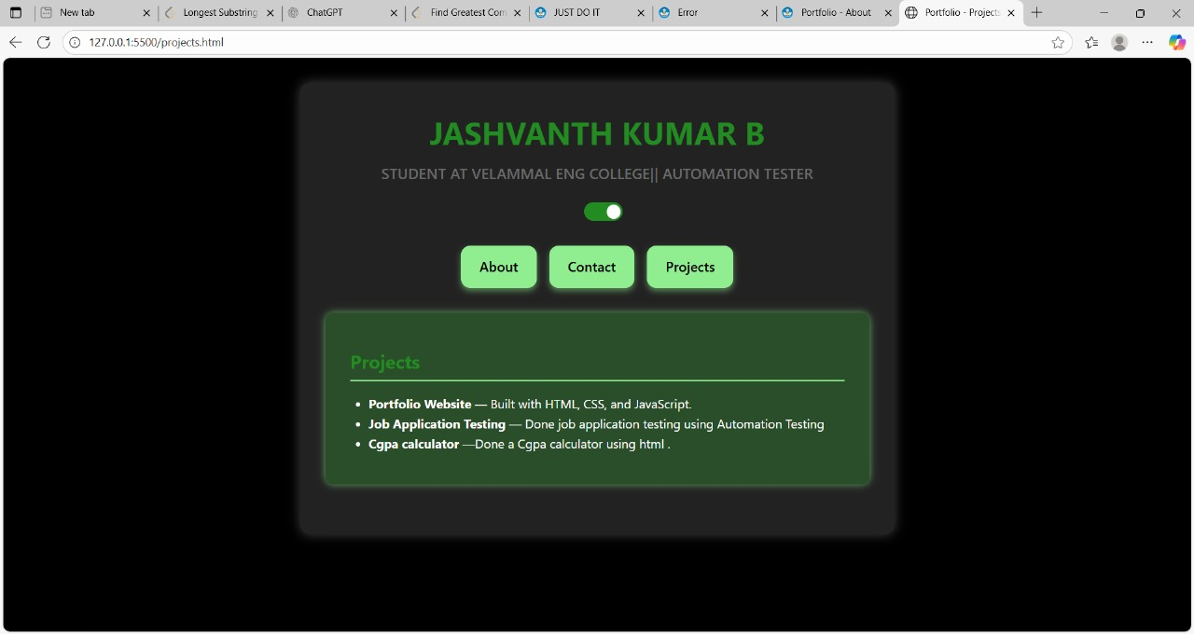

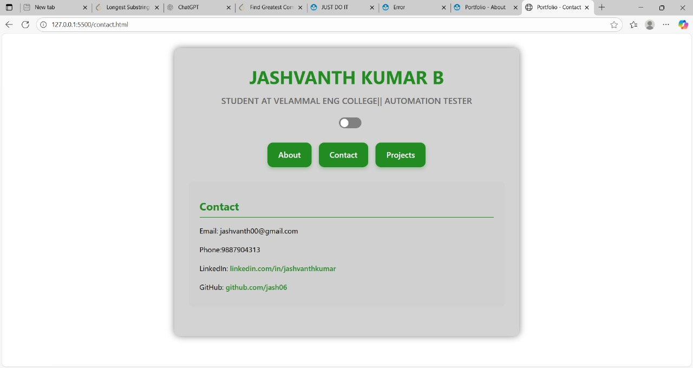

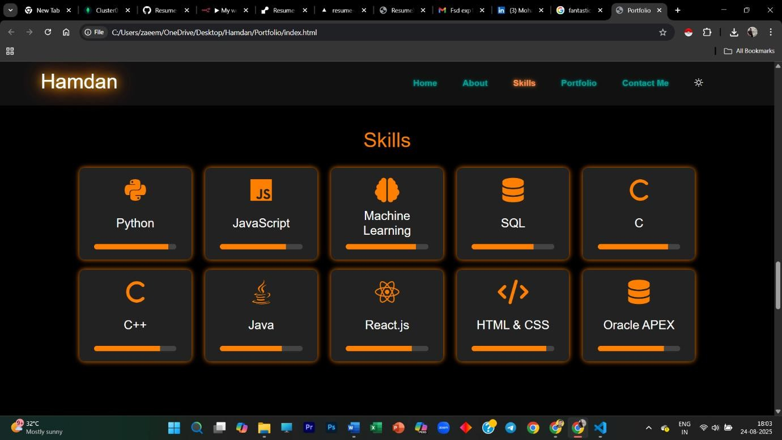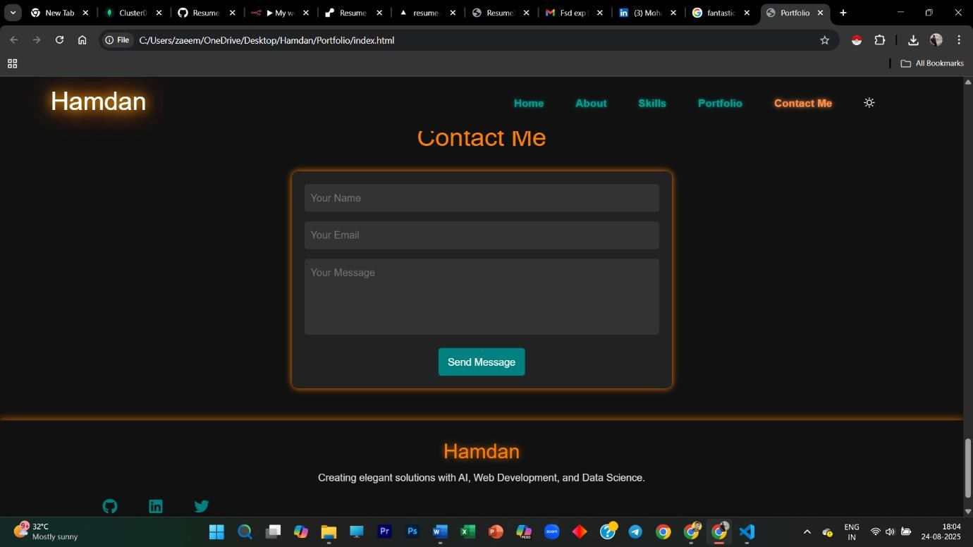

Result:
Thus, a potential portfolio of myself for a which gives details about myself for a potential recruiter is successfully created.

EXP NO.2: Create a web application to manage the TODO list of users, where users can login and manage their todo items

Aim:
To develop a frontend web application using HTML, CSS, and JavaScript that allows users to register/login (stored locally for demo purposes) and add, mark complete, and delete todo items. Data is stored per user using localStorage.
Algorithm:
Step1: Design the layout with a login/register card and a todo dashboard card.
Step 2: Use localStorage to persist `users` (username→password hash) and `todos` keyed by username.
Step3: On register: validate uniqueness of username and save a hashed password (simple demo hash).
Step4: On login: verify password hash; keep `currentUser` in memory (and optionally in localStorage).
Step5: Render the dashboard with a form to add tasks and a list showing each todo (text + done flag).
Step6: Implement Add: push a new item into the current user's todo list and rerender.
Step7: Implement Toggle: switch the `done` flag and re=render list.
Step8: Implement Delete: remove the selected item and re-render list.
Step9: Provide Logout to clear the session and return to the login screen.
Step10: Apply responsive styles (glassmorphism) to match the aesthetic of the reference document.footer.

Program:

index.html
<!DOCTYPE html>
<html lang="en">
<head>
<meta charset="UTF-8" />
<meta name="viewport" content="width=device-width, initial-scale=1.0"/>
<title>To-Do App</title>
<link rel="stylesheet" href="styles.css"/>
</head>
<body>
<main id="auth">
<section class="card">
<h1>To-Do Login</h1>
<label>Username <input id="loginUser" /></label>
<label>Password <input id="loginPass" type="password" /></label>
<div class="actions">
<button id="btnLogin">Login</button>
<button id="btnShowReg" class="ghost">Create account</button>
</div>
</section>

<section class="card hidden" id="registerCard">
<h1>Create Account</h1>
<label>Username <input id="regUser" /></label>
<label>Password <input id="regPass" type="password" /></label>
<div class="actions">
<button id="btnRegister">Register</button>
<button id="btnBack" class="ghost">Back</button>
</div>
<p id="regError" class="error"></p>
</section>
</main>

<main id="app" class="hidden">
<section class="card">
<header class="bar">
<h2 id="welcome"></h2>
<button id="btnLogout">Logout</button>
</header>
<form id="addForm">
<input id="todoText" placeholder="Add a task..." required />
<button>Add</button>
</form>
<ul id="list"></ul>
</section>
</main>

<script src="app.js"></script>
</body>
</html>

style.css
:root{
--bg1:#0f172a; --bg2:#1e293b; --fg:#e2e8f0; --accent:#60a5fa; -muted:#94a3b8;
--glass: rgba(255,255,255,0.08);
}
*{ box-sizing:border-box; }
html,body{ height:100%; margin:0; font-family:system-ui, -apple-system,
Segoe UI, Roboto, Arial; color:var(--fg); background: radial-gradient( circle at
20% 20%, #0b1220, #0f172a 40%, #111827 );} main{ min-height:100%; display:grid; place-items:center; padding:24px; }
.card{ width:min(720px, 94vw); background:var(--glass); backdrop-filter: blur(12px); border:1px solid rgba(255,255,255,0.12); border-radius:16px; padding:20px 20px 16px; box-shadow:0 10px 30px rgba(0,0,0,0.35);
}
.hidden{ display:none; } h1,h2{ margin:8px 0 12px; font-weight:700; letter-spacing:.3px; } label{ display:block; margin:8px 0; color:var(--muted); } input, textarea{
width:100%; padding:10px 12px; border-radius:10px; border:1px solid rgba(255,255,255,0.14); background:rgba(255,255,255,0.06); color:var(--fg);
}
.actions{ display:flex; gap:10px; margin-top:10px; } button{
padding:10px 14px; border-radius:10px; border:1px solid rgba(255,255,255,0.18); background:linear-gradient(180deg, rgba(255,255,255,0.06), rgba(255,255,255,0.02)); color:var(--fg); cursor:pointer;
} button.ghost{ background:transparent; }
.bar{ display:flex; justify-content:space-between; align-items:center; marginbottom:6px; }
#addForm{ display:flex; gap:8px; margin:8px 0 12px; } ul#list{ list-style:none; padding:0; margin:0; }
#list li{
display:flex; align-items:center; gap:10px; padding:8px 6px; borderbottom:1px dashed rgba(255,255,255,0.12);
}
#list li.done .text{ text-decoration: line-through; opacity:.7; }
.error{ color:#fca5a5; }

app.js const $ = (q) => document.querySelector(q); const usersKey = "todo_users"; const todosKey = "todo_data"; let currentUser = null;

function hash(s){ // demo hash (NOT secure)
let h=0; for (let i=0;i<s.length;i++){ h=((h<<5)-h)+s.charCodeAt(i); h|=0; } return String(h);
}
function loadUsers(){ return JSON.parse(localStorage.getItem(usersKey) ||
"{}"); }
function saveUsers(obj){ localStorage.setItem(usersKey, JSON.stringify(obj));
}
function loadTodos(){ return JSON.parse(localStorage.getItem(todosKey) ||
"{}"); }
function saveTodos(obj){ localStorage.setItem(todosKey, JSON.stringify(obj)); }

function showApp(user){ currentUser = user;
$("#auth").classList.add("hidden");
$("#app").classList.remove("hidden");
$("#welcome").textContent = `Welcome, ${user}`; renderList();
} function showAuth(){
$("#app").classList.add("hidden");
$("#auth").classList.remove("hidden");
$("#registerCard").classList.add("hidden");
}

$("#btnShowReg").onclick = () =>
$("#registerCard").classList.remove("hidden");
$("#btnBack").onclick = () => $("#registerCard").classList.add("hidden"); $("#btnRegister").onclick = () => { const u = $("#regUser").value.trim(); const p = $("#regPass").value; if(!u || !p){ $("#regError").textContent = "Enter username/password"; return; } const users = loadUsers(); if(users[u]){ $("#regError").textContent = "Username already exists"; return; } users[u] = hash(p); saveUsers(users);
$("#regError").textContent = "Account created. You can login now."; };

$("#btnLogin").onclick = () => { const u = $("#loginUser").value.trim(); const p = $("#loginPass").value; const users = loadUsers();
if(users[u] && users[u] === hash(p)){ showApp(u); } else { alert("Invalid credentials"); }
};

$("#btnLogout").onclick = () => { currentUser=null; showAuth(); };

$("#addForm").onsubmit = (e) => {
e.preventDefault(); const txt = $("#todoText").value.trim(); if(!txt) return;
const store = loadTodos(); store[currentUser] = store[currentUser] || []; store[currentUser].unshift({ text: txt, done:false, id: Date.now() }); saveTodos(store); $("#todoText").value = ""; renderList();
};

function renderList(){ const store = loadTodos(); const items = store[currentUser] || []; const list = $("#list"); list.innerHTML = ""; items.forEach(item => { const li = document.createElement("li"); if(item.done) li.classList.add("done"); li.innerHTML = `
<input type="checkbox" ${item.done ? "checked":""} data-id="${item.id}" class="toggle">
<span class="text">${item.text}</span>
<button class="del" data-id="${item.id}">🗑</button>
`;
list.appendChild(li);
}); list.onclick = (e) => { const id = Number(e.target.getAttribute("data-id")); if(e.target.classList.contains("toggle")){ toggleItem(id);
}else if(e.target.classList.contains("del")){ deleteItem(id);
}
};
}

function toggleItem(id){ const store = loadTodos(); const arr = store[currentUser] || []; const idx = arr.findIndex(x => x.id===id); if(idx>-1){ arr[idx].done = !arr[idx].done; saveTodos(store); renderList(); } }

function deleteItem(id){ const store = loadTodos(); store[currentUser] = (store[currentUser] || []).filter(x => x.id!==id); saveTodos(store); renderList();
}

Output:
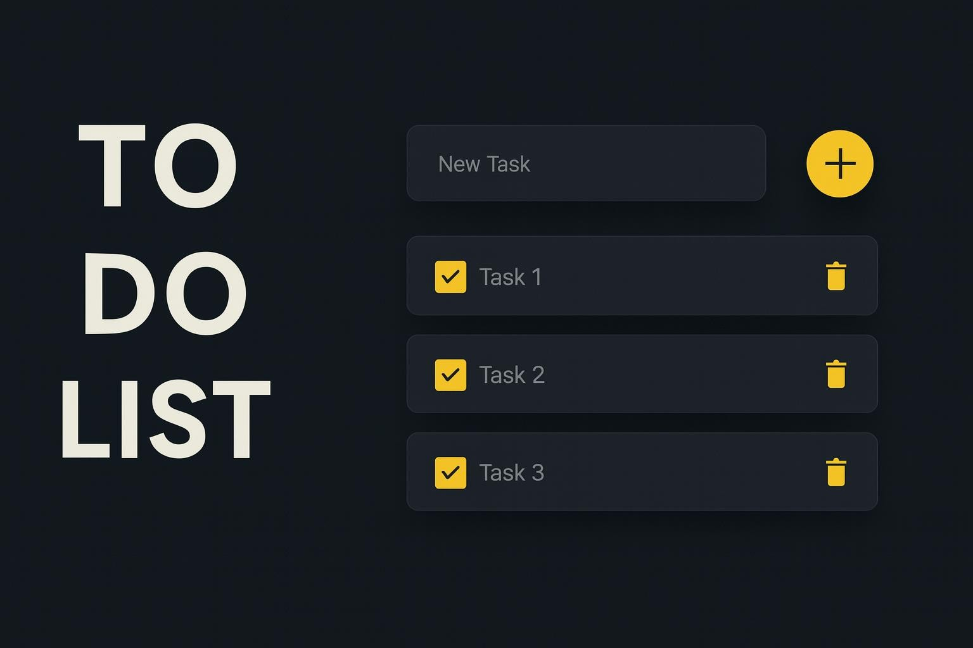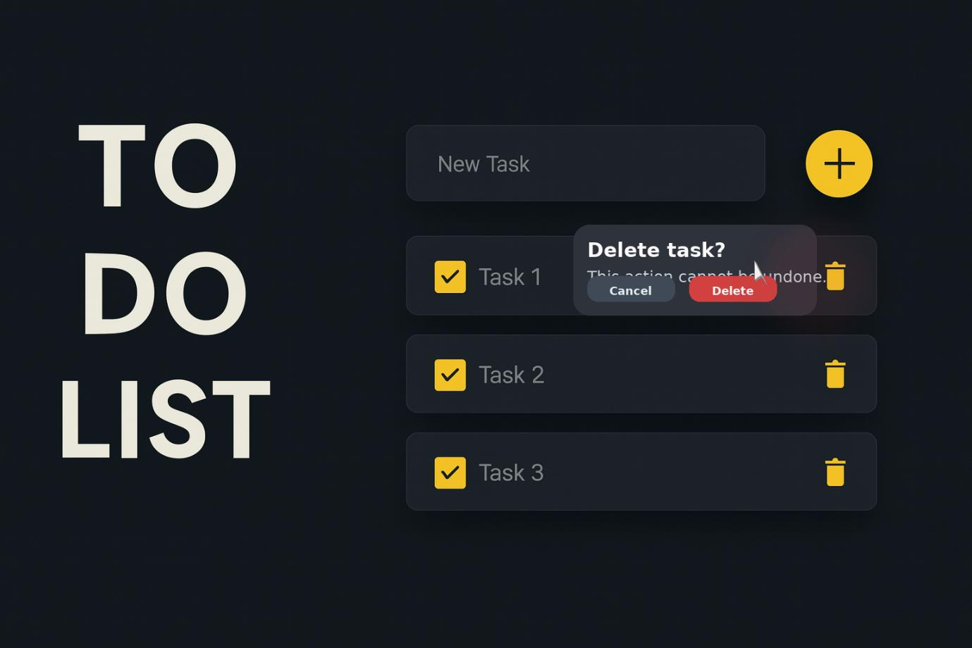
Result:
Thus, the web application for user registration, login, and to-do list management was successfully developed and executed
EXP NO.3: Create a Simple Micro Blogging Application (Twitter like) with Follows & Feed

Aim:
To design and implement a minimal Twitter like web application where users can post short updates, follow other users, and view a personalized timeline of posts from accounts they follow.

Algorithm:
Step1: Initialize project and install dependencies. • • •. •. • •
Step 2: Set up Express, EJS, static assets, sessions, and SQLite database.
Step 3: Create tables: users, posts(id, user_id, content, created_at), follows(follower_id, followee_id).
Step 4: Implement auth routes for registration, login, logout.
Step 5: Build core routes: /post (create), /feed (timeline), /u/:username (profile), /follow/:id, /unfollow/:id
Step 6: Restrict posting/follow actions to authenticated users; profile and feed guarded behind auth
Step 7: Render templates for feed and profile with follow/unfollow buttons.
Step 8: Test posting, following, and timeline ordering.
Program:

index.html
<!DOCTYPE html>
<html lang="en">
<head>
<meta charset="UTF-8" />
<meta name="viewport" content="width=device-width, initial-scale=1.0"/> <title>Microblog</title>
<link rel="stylesheet" href="styles.css"/>
</head>
<body>
<main id="auth">
<section class="card">
<h1>Microblog Login</h1>
<label>Username <input id="loginUser" /></label>
<label>Password <input id="loginPass" type="password" /></label>
<div class="actions">
<button id="btnLogin">Login</button>
<button id="btnShowReg" class="ghost">Create account</button>
</div>
</section>

<section class="card hidden" id="registerCard">
<h1>Create Account</h1>
<label>Username <input id="regUser" /></label>
<label>Password <input id="regPass" type="password" /></label>
<div class="actions">
<button id="btnRegister">Register</button>
<button id="btnBack" class="ghost">Back</button>
</div>
<p id="regError" class="error"></p>
</section>
</main>

<main id="app" class="hidden">
<section class="card">
<header class="bar">
<h2 id="welcome"></h2>
<button id="btnLogout">Logout</button>
</header>

<section class="composer">
<textarea id="postText" maxlength="280" placeholder="What's happening?"></textarea>
<button id="btnPost">Post</button>
</section>

<section class="grid">
<div>
<h3>Home Feed</h3>
<ul id="feed"></ul>
</div>
<aside>
<h3>People</h3>
<ul id="people"></ul>
</aside>
</section>
</section>
</main>

<script src="app.js"></script>
</body>
</html>

style.css
:root{
--bg:#0b1020; --panel:rgba(255,255,255,0.08); --text:#e6eef7; -muted:#a6b0c0;
}
*{ box-sizing:border-box; }
html,body{ height:100%; margin:0; font-family:system-ui, -apple-system,
Segoe UI, Roboto, Arial; color:var(--text); background: radial-gradient( circle at
20% 20%, #0b1020, #0f172a 40%, #0b1324 );} main{ min-height:100%; display:grid; place-items:center; padding:24px; }
.card{
width:min(900px, 96vw); background:var(--panel); backdrop-filter: blur(12px);
border:1px solid rgba(255,255,255,0.12); border-radius:16px; padding:18px; box-shadow:0 10px 30px rgba(0,0,0,0.35);
}
.hidden{ display:none; } h1,h2,h3{ margin:6px 0 10px; } label{ display:block; margin:8px 0; color:var(--muted); }
input, textarea{ width:100%; padding:10px; border-radius:10px; border:1px solid rgba(255,255,255,0.14); background:rgba(255,255,255,0.06); color:var(-text); }
.actions{ display:flex; gap:10px; margin-top:10px; }
button{ padding:10px 14px; border-radius:10px; border:1px solid rgba(255,255,255,0.18); background:linear-gradient(180deg, rgba(255,255,255,0.06), rgba(255,255,255,0.02)); color:var(--text); cursor:pointer; } button.ghost{ background:transparent; }
.bar{ display:flex; justify-content:space-between; align-items:center; }
.composer{ display:flex; gap:8px; margin:12px 0; }
.grid{ display:grid; grid-template-columns:2fr 1fr; gap:18px; }
#feed, #people{ list-style:none; padding:0; margin:0; }
#feed li{ padding:10px 8px; border-bottom:1px dashed rgba(255,255,255,0.12); }
#feed li .by{ color:var(--muted); font-size:12px; }
#people li{ display:flex; justify-content:space-between; align-items:center; padding:8px 6px; border-bottom:1px dashed rgba(255,255,255,0.12); }
@media (max-width:720px){
.grid{ grid-template-columns:1fr; }
}

app.js const $ = (q) => document.querySelector(q); const usersKey = "mb_users"; const postsKey = "mb_posts"; const followsKey = "mb_follows"; let currentUser = null;

function hash(s){ let h=0; for(let i=0;i<s.length;i++){ h=((h<<5)h)+s.charCodeAt(i); h|=0; } return String(h); } const load = (k, d) => JSON.parse(localStorage.getItem(k) || JSON.stringify(d)); const save = (k, v) => localStorage.setItem(k, JSON.stringify(v));

function showApp(user){ currentUser=user;
$("#auth").classList.add("hidden");
$("#app").classList.remove("hidden"); $("#welcome").textContent = `@${user}`; renderPeople(); renderFeed();
}

$("#btnShowReg").onclick = () =>
$("#registerCard").classList.remove("hidden");
$("#btnBack").onclick = () => $("#registerCard").classList.add("hidden");

$("#btnRegister").onclick = () => { const u = $("#regUser").value.trim(); const p = $("#regPass").value; if(!u || !p) return; const users = load(usersKey, {}); if(users[u]){ $("#regError").textContent = "Username exists"; return; } users[u]=hash(p); save(usersKey, users);
$("#regError").textContent = "Account created. You can login now."; };

$("#btnLogin").onclick = () => { const u = $("#loginUser").value.trim(); const p = $("#loginPass").value; const users = load(usersKey, {}); if(users[u] && users[u]===hash(p)) showApp(u); else alert("Invalid credentials");
};

$("#btnLogout").onclick = () => { currentUser=null;
$("#app").classList.add("hidden"); $("#auth").classList.remove("hidden"); };

$("#btnPost").onclick = () => { const text = $("#postText").value.trim(); if(!text || text.length>280) return; const posts = load(postsKey, []);
posts.unshift({ id: Date.now(), by: currentUser, text, at: new Date().toISOString() }); save(postsKey, posts); $("#postText").value = ""; renderFeed();
};

function renderPeople(){ const users = load(usersKey, {}); const follows = load(followsKey, []); const list = $("#people"); list.innerHTML = ""; Object.keys(users).forEach(u => {
if(!u) return; const li = document.createElement("li"); const isMe = u===currentUser;
const isFollowing = follows.some(f => f.follower===currentUser && f.followee===u); li.innerHTML = `<span>@${u}</span>` +
(isMe ? `<span class="by">you</span>` :
`<button data-user="${u}" class="fbtn">${isFollowing?'Unfollow':'Follow'}</button>`); list.appendChild(li);
}); list.onclick = (e) => { if(e.target.classList.contains("fbtn")){ const u = e.target.getAttribute("data-user"); toggleFollow(u); renderPeople(); renderFeed();
}
};
}

function toggleFollow(u){ const follows = load(followsKey, []);
const idx = follows.findIndex(f => f.follower===currentUser && f.followee===u); if(idx>-1) follows.splice(idx,1);
else follows.push({ follower: currentUser, followee: u }); save(followsKey, follows);
}

function renderFeed(){ const posts = load(postsKey, []); const follows = load(followsKey, []);
const following = new Set([currentUser, ...follows.filter(f => f.follower===currentUser).map(f => f.followee)]); const feed = posts.filter(p => following.has(p.by)); const ul = $("#feed"); ul.innerHTML = ""; feed.forEach(p => { const li = document.createElement("li"); const dt = new Date(p.at).toLocaleString();
li.innerHTML = `<div class="by">@${p.by} • ${dt}</div><div>${p.text}</div>`; ul.appendChild(li);
});
}

Output:
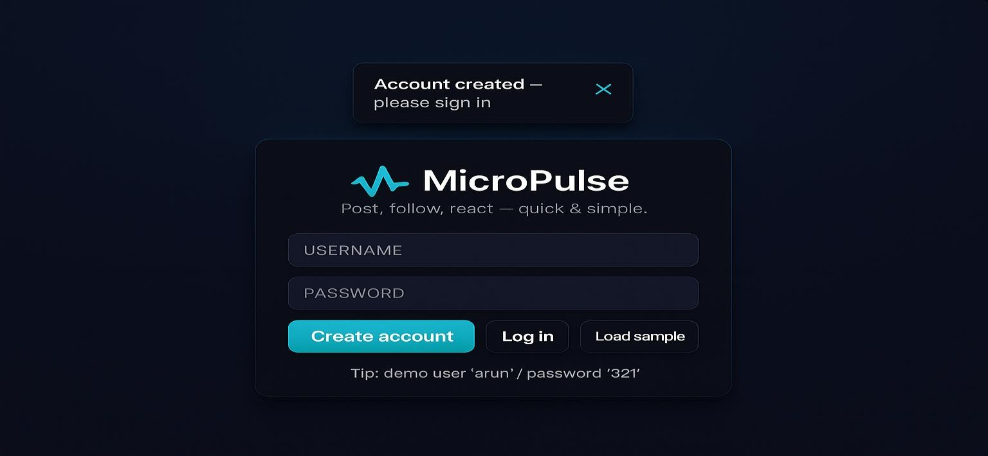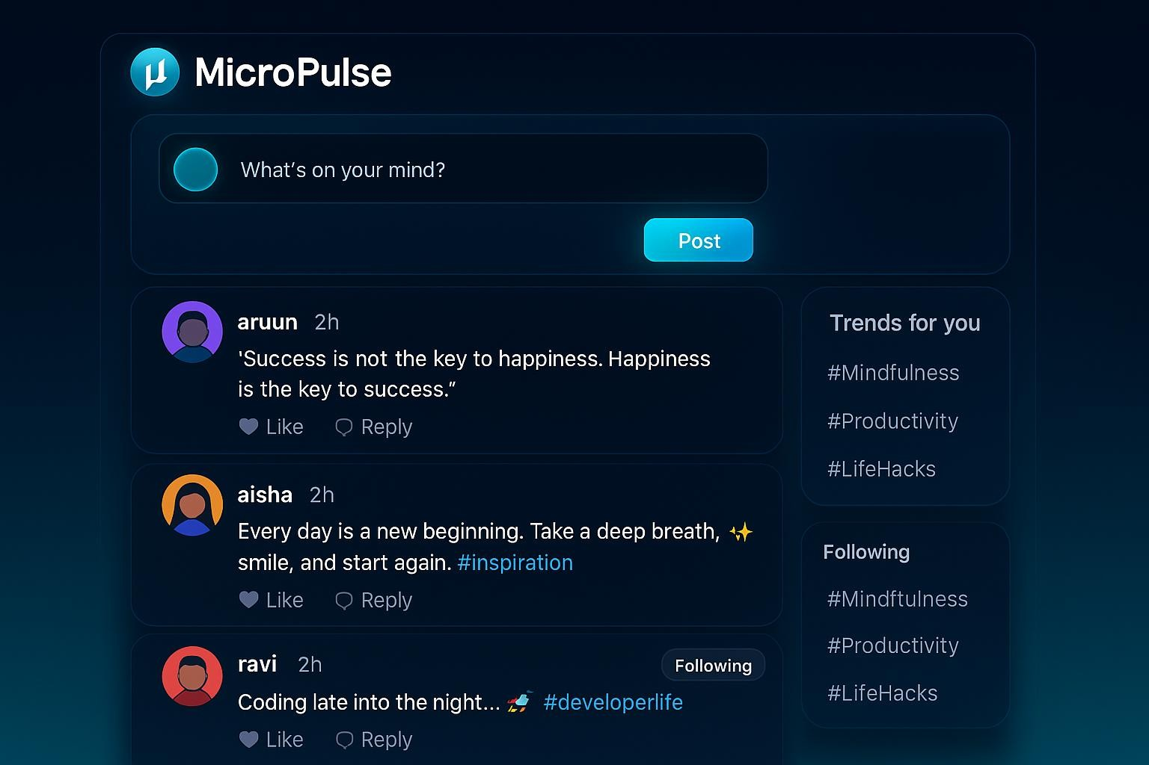
Result:
The Micro Pulse application was successfully developed and executed. Users are able to log in, create posts, and view them in the feed with basic functionalities like explore and people tabs working correctly.

